**S3 Versioning**

Step 1 – For ex I added one more file in S3 object – style.css.

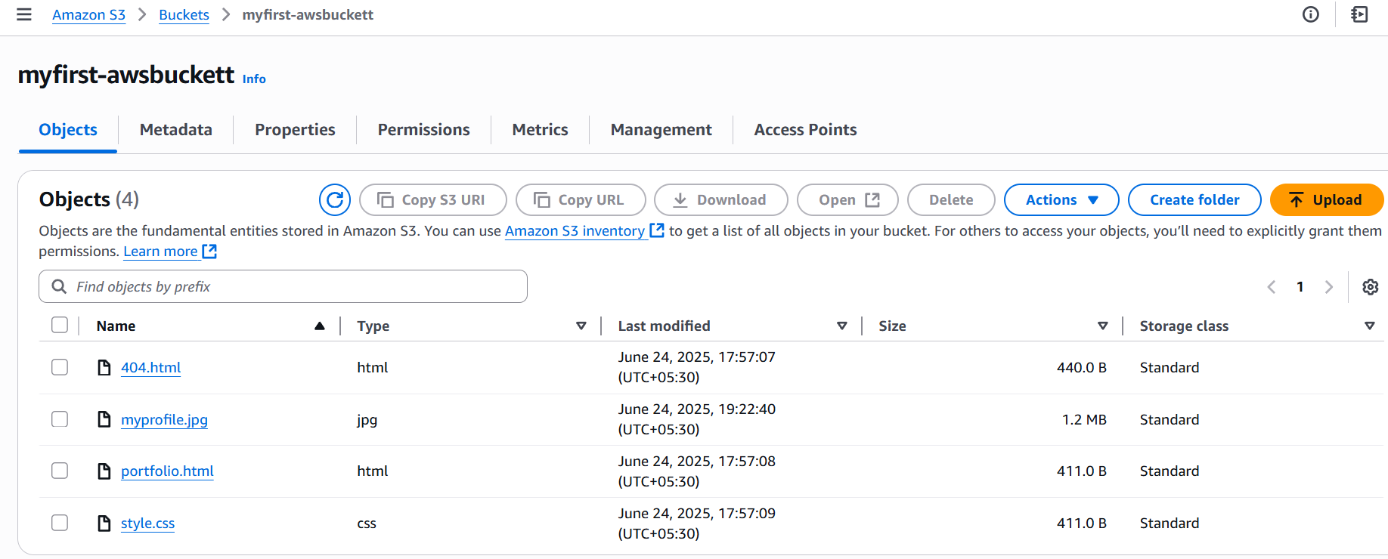

Go to properties- Bucket versioning and enable it.

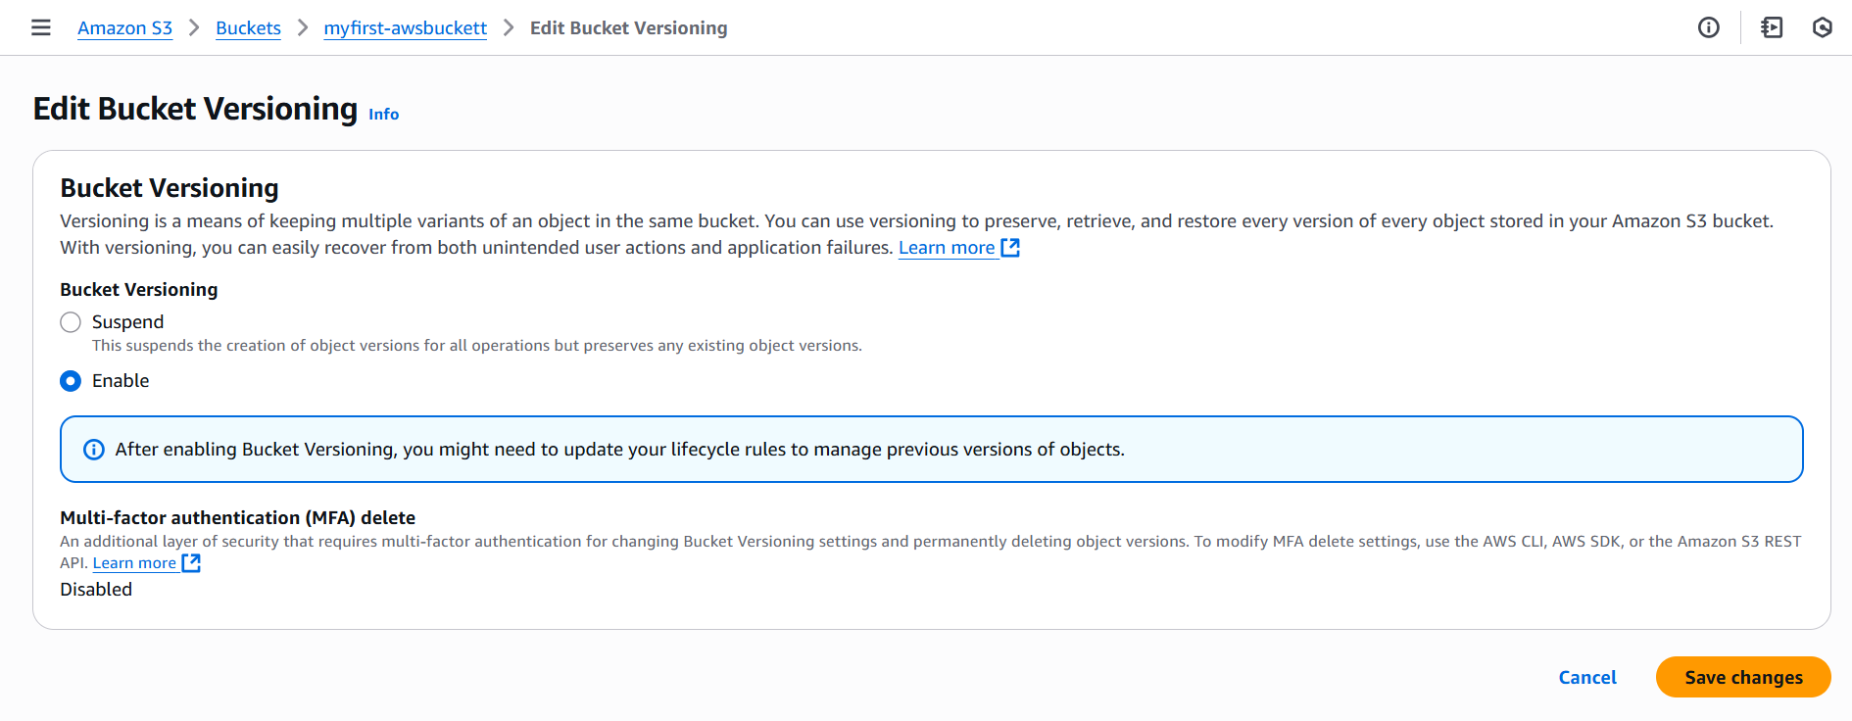

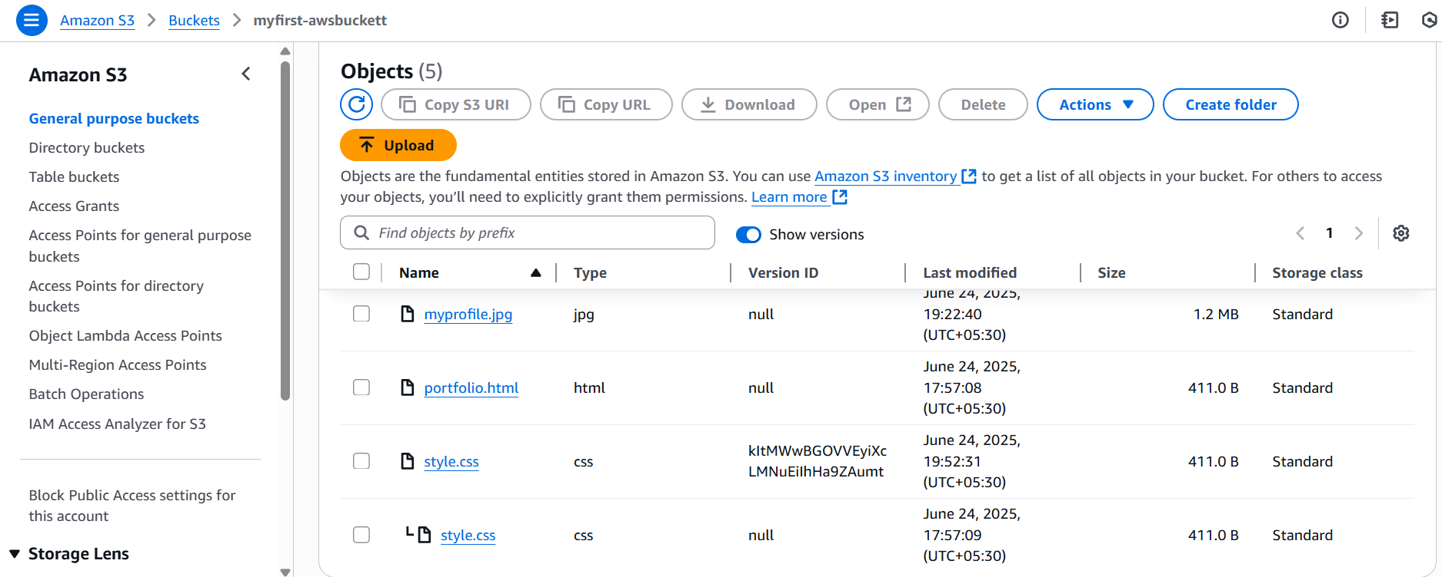

Now you can enable show versions option and see the style.css has one more file attached with additional content( download file and check the updated content ).